**Jalu Chaudhary**

**Class IT-314-DL1**

**Hand-on Assignment- PL/SQL Packages and Database Trigger**

**Assignment 7-9: Creating a Package for Pledges**

Create a package named PLEDGE_PKG that includes two functions for determining dates of

pledge payments. Use or create the functions described in Chapter 6 for Assignments 6-12 and

6-13, using the names DD_PAYDATE1_PF and DD_PAYEND_PF for these packaged functions.

Test both functions with a specific pledge ID, using an anonymous block. Then test both

functions in a single query showing all pledges and associated payment dates.

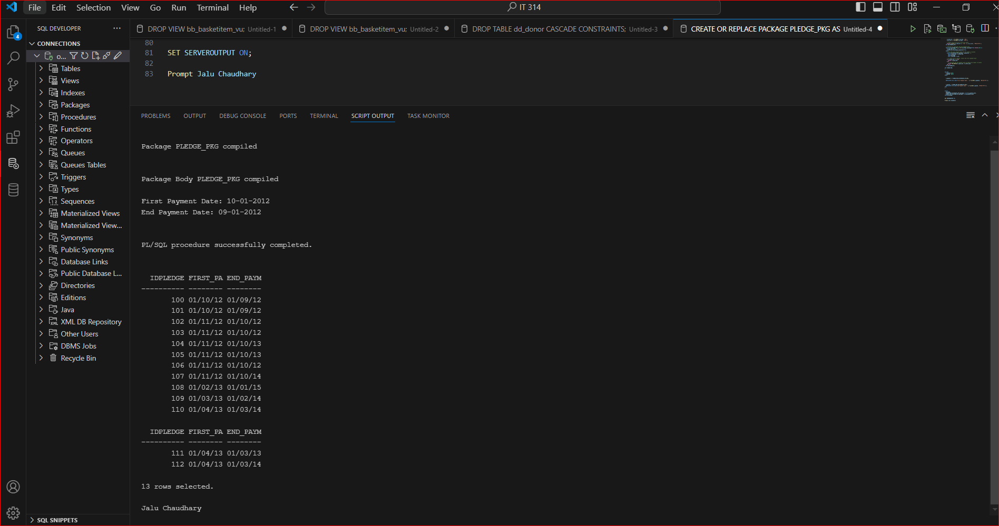

**Assignment 7-10: Adding a Pledge Display Procedure to the Package**

Modify the package created in Assignment 7-9 as follows:

• Add a procedure named DD_PLIST_PP that displays the donor name and all

associated pledges (including pledge ID, first payment due date, and last payment

due date). A donor ID is the input value for the procedure.

• Make the procedure public and the two functions private.

Test the procedure with an anonymous block.

**Assignment 7-11: Adding a Payment Retrieval Procedure to the Package**

Modify the package created in Assignment 7-10 as follows:

• Add a new procedure named DD_PAYS_PP that retrieves donor pledge payment

information and returns all the required data via a single parameter.

• A donor ID is the input for the procedure.

• The procedure should retrieve the donor’s last name and each pledge payment

made so far (including payment amount and payment date).

• Make the procedure public.

**Assignment 9-9: Tracking Pledge Payment Activity**

The DoGood Donor organization wants to track all pledge payment activity. Each time a pledge payment is added, changed, or removed, the following information should be captured in a separate table: username (logon), current date, action taken (INSERT, UPDATE, or DELETE), and the idpay value for the payment record. Create a table named DD_PAYTRACK to hold this information. Include a primary key column to be populated by a sequence, and create a new sequence named DD_PTRACK_SEQ for the primary key column. Create a single trigger for recording the requested information to track pledge payment activity, and test the trigger.

